**How to deploy Kubernetes Dashboard quickly and easily**

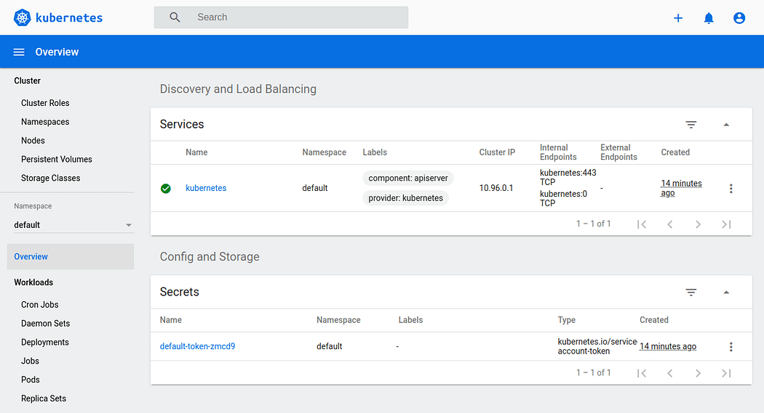

Kubernetes offers a convenient graphical user interface with their [web dashboard](https://kubernetes.io/docs/tasks/access-application-cluster/web-ui-dashboard/) which can be used to create, monitor and manage a cluster. The installation is quite straightforward but takes a few steps to set up everything in a convenient manner.

In addition to deploying the dashboard, we’ll go over how to set up both admin and read-only access to the dashboard. However, before we begin, we need to have a working Kubernetes cluster. You can [get started with Kubernetes by following our earlier tutorial.](https://upcloud.com/community/%20/tutorials/install-kubernetes-cluster-centos-8/)

We’ve launched the [UpCloud Managed Kubernetes](https://upcloud.com/products/managed-kubernetes" \t "_blank), a fully managed container orchestration service with all the benefits of a self-maintained system but without any of the headaches! See how [quick and easy it is to get started](https://upcloud.com/resources/tutorials/get-started-managed-kubernetes) by following our dedicated tutorial.

[Try UpCloud for free!](https://signup.upcloud.com/)

**1. Deploy the latest Kubernetes dashboard**

Once you’ve set up your Kubernetes cluster or if you already had one running, we can get started.

The first thing to know about the web UI is that it can only be accessed using localhost address on the machine it runs on. This means we need to have an SSH tunnel to the server. For most OS, you can create an SSH tunnel using this command. Replace the <user> and <master\_public\_IP> with the relevant details to your Kubernetes cluster.

ssh -L localhost:8001:127.0.0.1:8001 <user>@<master\_public\_IP>

After you’ve logged in, you can deploy the dashboard itself with the following single command.

kubectl apply -f https://raw.githubusercontent.com/kubernetes/dashboard/v2.0.0/aio/deploy/recommended.yaml

If your cluster is working correctly, you should see an output confirming the creation of a bunch of Kubernetes components as in the example below.

namespace/kubernetes-dashboard created  
serviceaccount/kubernetes-dashboard created  
service/kubernetes-dashboard created  
secret/kubernetes-dashboard-certs created  
secret/kubernetes-dashboard-csrf created  
secret/kubernetes-dashboard-key-holder created  
configmap/kubernetes-dashboard-settings created  
role.rbac.authorization.k8s.io/kubernetes-dashboard created  
clusterrole.rbac.authorization.k8s.io/kubernetes-dashboard created  
rolebinding.rbac.authorization.k8s.io/kubernetes-dashboard created  
clusterrolebinding.rbac.authorization.k8s.io/kubernetes-dashboard created  
deployment.apps/kubernetes-dashboard created  
service/dashboard-metrics-scraper created  
deployment.apps/dashboard-metrics-scraper created

Afterwards, you should have two new pods running on your cluster.

kubectl get pods -A

...  
kubernetes-dashboard dashboard-metrics-scraper-6b4884c9d5-v4z89 1/1 Running 0 30m  
kubernetes-dashboard kubernetes-dashboard-7b544877d5-m8jzk 1/1 Running 0 30m

You can then continue ahead with creating the required user accounts.

**2. Creating Admin user**

The Kubernetes dashboard supports a few ways to manage access control. In this example, we’ll be creating an admin user account with full privileges to modify the cluster and using tokens.

Start by making a new directory for the dashboard configuration files.

mkdir ~/dashboard && cd ~/dashboard

Create the following configuration and save it as dashboard-admin.yaml file. Note that indentation matters in the YAML files which should use two spaces in a regular text editor.

nano dashboard-admin.yaml

apiVersion: v1  
kind: ServiceAccount  
metadata:  
 name: admin-user  
 namespace: kubernetes-dashboard  
---  
apiVersion: rbac.authorization.k8s.io/v1  
kind: ClusterRoleBinding  
metadata:  
 name: admin-user  
roleRef:  
 apiGroup: rbac.authorization.k8s.io  
 kind: ClusterRole  
 name: cluster-admin  
subjects:  
- kind: ServiceAccount  
 name: admin-user  
 namespace: kubernetes-dashboard

Once set, save the file and exit the editor.

Then deploy the admin user role with the next command.

kubectl apply -f dashboard-admin.yaml

You should see a service account and a cluster role binding created.

serviceaccount/admin-user created  
clusterrolebinding.rbac.authorization.k8s.io/admin-user created

Using this method doesn’t require setting up or memorising passwords, instead, accessing the dashboard will require a token.

Get the admin token using the command below.

kubectl get secret -n kubernetes-dashboard $(kubectl get serviceaccount admin-user -n kubernetes-dashboard -o jsonpath="{.secrets[0].name}") -o jsonpath="{.data.token}" | base64 --decode

You’ll then see an output of a long string of seemingly random characters like in the example below.

eyJhbGciOiJSUzI1NiIsImtpZCI6Ilk2eEd2QjJMVkhIRWNfN2xTMlA5N2RNVlR5N0o1REFET0dp  
dkRmel90aWMifQ.eyJpc3MiOiJrdWJlcm5ldGVzL3NlcnZpY2VhY2NvdW50Iiwia3ViZXJuZXRlc  
y5pby9zZXJ2aWNlYWNjb3VudC9uYW1lc3BhY2UiOiJrdWJlcm5ldGVzLWRhc2hib2FyZCIsImt1Y  
mVybmV0ZXMuaW8vc2VydmljZWFjY291bnQvc2VjcmV0Lm5hbWUiOiJhZG1pbi11c2VyLXRva2VuL  
XEyZGJzIiwia3ViZXJuZXRlcy5pby9zZXJ2aWNlYWNjb3VudC9zZXJ2aWNlLWFjY291bnQubmFtZ  
SI6ImFkbWluLXVzZXIiLCJrdWJlcm5ldGVzLmlvL3NlcnZpY2VhY2NvdW50L3NlcnZpY2UtYWNjb  
3VudC51aWQiOiI1ODI5OTUxMS1hN2ZlLTQzZTQtODk3MC0yMjllOTM1YmExNDkiLCJzdWIiOiJze  
XN0ZW06c2VydmljZWFjY291bnQ6a3ViZXJuZXRlcy1kYXNoYm9hcmQ6YWRtaW4tdXNlciJ9.GcUs  
MMx4GnSV1hxQv01zX1nxXMZdKO7tU2OCu0TbJpPhJ9NhEidttOw5ENRosx7EqiffD3zdLDptS22F  
gnDqRDW8OIpVZH2oQbR153EyP\_l7ct9\_kQVv1vFCL3fAmdrUwY5p1-YMC41OUYORy1JPo5wkpXrW  
OytnsfWUbZBF475Wd3Gq3WdBHMTY4w3FarlJsvk76WgalnCtec4AVsEGxM0hS0LgQ-cGug7iGbmf  
cY7odZDaz5lmxAflpE5S4m-AwsTvT42ENh\_bq8PS7FsMd8mK9nELyQu\_a-yocYUggju\_m-BxLjgc  
2cLh5WzVbTH\_ztW7COlKWvSVbhudjwcl6w

The token is created each time the dashboard is deployed and is required to log into the dashboard. Note that the token will change if the dashboard is stopped and redeployed.

**3. Creating Read-Only user**

If you wish to provide access to your Kubernetes dashboard, for example, for demonstrative purposes, you can create a read-only view for the cluster.

Similarly to the admin account, save the following configuration in dashboard-read-only.yaml

nano dashboard-read-only.yaml

apiVersion: v1  
kind: ServiceAccount  
metadata:  
 name: read-only-user  
 namespace: kubernetes-dashboard  
---  
apiVersion: rbac.authorization.k8s.io/v1  
kind: ClusterRole  
metadata:  
 annotations:  
 rbac.authorization.kubernetes.io/autoupdate: "true"  
 labels:  
 name: read-only-clusterrole  
 namespace: default  
rules:  
- apiGroups:  
 - ""  
 resources: ["\*"]  
 verbs:  
 - get  
 - list  
 - watch  
- apiGroups:  
 - extensions  
 resources: ["\*"]  
 verbs:  
 - get  
 - list  
 - watch  
- apiGroups:  
 - apps  
 resources: ["\*"]  
 verbs:  
 - get  
 - list  
 - watch  
---  
apiVersion: rbac.authorization.k8s.io/v1  
kind: ClusterRoleBinding  
metadata:  
 name: read-only-binding  
roleRef:  
 kind: ClusterRole  
 name: read-only-clusterrole  
 apiGroup: rbac.authorization.k8s.io  
subjects:  
- kind: ServiceAccount  
 name: read-only-user  
 namespace: kubernetes-dashboard

Once set, save the file and exit the editor.

Then deploy the read-only user account with the command below.

kubectl apply -f dashboard-read-only.yaml

To allow users to log in via the read-only account, you’ll need to provide a token which can be fetched using the next command.

kubectl get secret -n kubernetes-dashboard $(kubectl get serviceaccount read-only-user -n kubernetes-dashboard -o jsonpath="{.secrets[0].name}") -o jsonpath="{.data.token}" | base64 --decode

The toke will be a long series of characters unique to the dashboard currently running.

**4. Accessing the dashboard**

We’ve now deployed the dashboard and created user accounts for it. Next, we can get started managing the Kubernetes cluster itself.

However, before we can log in to the dashboard, it needs to be made available by creating a proxy service on the localhost. Run the next command on your Kubernetes cluster.

kubectl proxy

This will start the server at 127.0.0.1:8001 as shown by the output.

Starting to serve on 127.0.0.1:8001

Now, assuming that we have already established an SSH tunnel binding to the localhost port 8001 at both ends, open a browser to the link below.

http://localhost:8001/api/v1/namespaces/kubernetes-dashboard/services/https:kubernetes-dashboard:/proxy/

If everything is running correctly, you should see the dashboard login window.

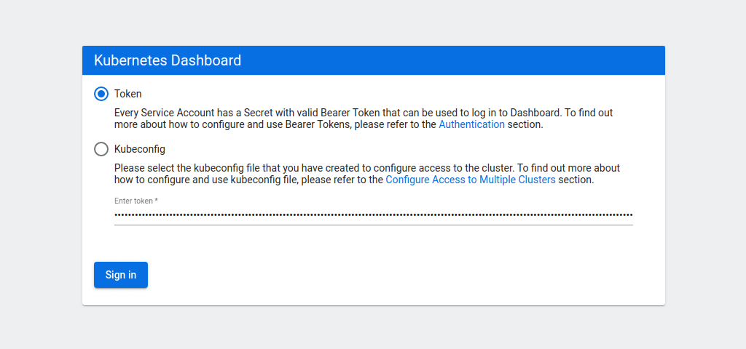

Select the token authentication method and copy your admin token into the field below. Then click the Sign in button.

You will then be greeted by the overview of your Kubernetes cluster.



While signed in as an admin, you can deploy new pods and services quickly and easily by clicking the plus icon at the top right corner of the dashboard.

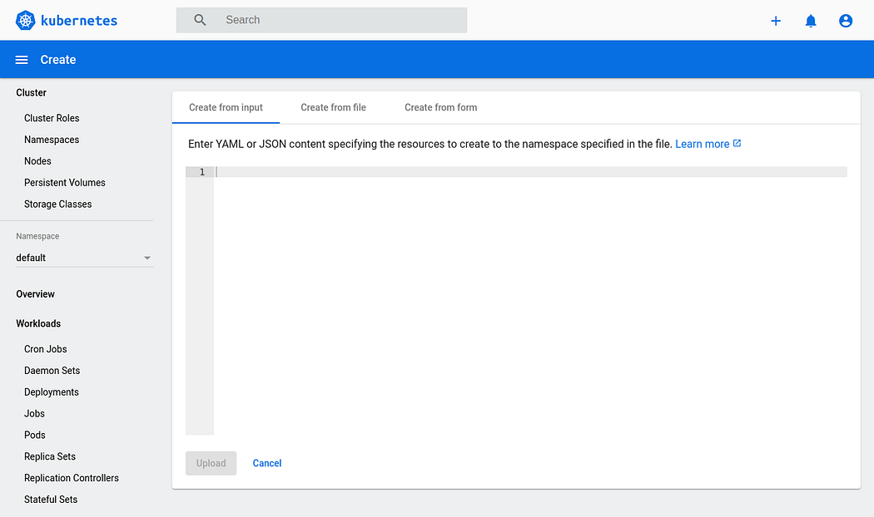

Then either copy in any configuration file you wish, select the file directly from your machine or create a new configuration from a form.

**5. Stopping the dashboard**

User roles that are no longer needed can be removed using the delete method.

kubectl delete -f dashboard-admin.yaml  
kubectl delete -f dashboard-read-only.yaml

Likewise, if you want to disable the dashboard, it can be deleted just like any other deployment.

kubectl delete -f https://raw.githubusercontent.com/kubernetes/dashboard/v2.0.0/aio/deploy/recommended.yaml

The dashboard can then be redeployed at any time following the same procedure as before.

**6. Setting up management script**

The steps to deploy or delete the dashboard are not complicated but they can be further simplified.

The following script can be used to start, stop or check the dashboard status.

nano ~/dashboard/dashboard.sh

#!/bin/bash  
showtoken=1  
cmd="kubectl proxy"  
count=`pgrep -cf "$cmd"`  
dashboard\_yaml="https://raw.githubusercontent.com/kubernetes/dashboard/v2.0.0/aio/deploy/recommended.yaml"  
msgstarted="-e Kubernetes Dashboard e[92mstartede[0m"  
msgstopped="Kubernetes Dashboard stopped"

case $1 in  
start)  
 kubectl apply -f $dashboard\_yaml >/dev/null 2>&1  
 kubectl apply -f ~/dashboard/dashboard-admin.yaml >/dev/null 2>&1  
 kubectl apply -f ~/dashboard/dashboard-read-only.yaml >/dev/null 2>&1 if [ $count = 0 ]; then  
 nohup $cmd >/dev/null 2>&1 &  
 echo $msgstarted  
 else  
 echo "Kubernetes Dashboard already running"  
 fi  
 ;;stop)  
 showtoken=0  
 if [ $count -gt 0 ]; then  
 kill -9 $(pgrep -f "$cmd")  
 fi  
 kubectl delete -f $dashboard\_yaml >/dev/null 2>&1  
 kubectl delete -f ~/dashboard/dashboard-admin.yaml >/dev/null 2>&1  
 kubectl delete -f ~/dashboard/dashboard-read-only.yaml >/dev/null 2>&1  
 echo $msgstopped  
 ;;status)  
 found=`kubectl get serviceaccount admin-user -n kubernetes-dashboard 2>/dev/null`  
 if [[ $count = 0 ]] || [[ $found = "" ]]; then  
 showtoken=0  
 echo $msgstopped  
 else  
 found=`kubectl get clusterrolebinding admin-user -n kubernetes-dashboard 2>/dev/null`  
 if [[ $found = "" ]]; then  
 nopermission=" but user has no permissions."  
 echo $msgstarted$nopermission  
 echo 'Run "dashboard start" to fix it.'  
 else  
 echo $msgstarted  
 fi  
 fi  
 ;;  
esac# Show full command line # ps -wfC "$cmd"  
if [ $showtoken -gt 0 ]; then  
 # Show token  
 echo "Admin token:"  
 kubectl get secret -n kubernetes-dashboard $(kubectl get serviceaccount admin-user -n kubernetes-dashboard -o jsonpath="{.secrets[0].name}") -o jsonpath="{.data.token}" | base64 --decode  
 echo echo "User read-only token:"  
 kubectl get secret -n kubernetes-dashboard $(kubectl get serviceaccount read-only-user -n kubernetes-dashboard -o jsonpath="{.secrets[0].name}") -o jsonpath="{.data.token}" | base64 --decode  
 echo  
fi

Once all set, save the file and exit the text editor.

Then make the script executable.

chmod +x ~/dashboard/dashboard.sh

Next, create a symbolic link to the dashboard script to be able to run it from anywhere on the system.

sudo ln -s ~/dashboard/dashboard.sh /usr/local/bin/dashboard

You can then use the following commands to run the dashboard like an application.

Start the dashboard and show the tokens

dashboard start

Check whether the dashboard is running or not and output the tokens if currently set.

dashboard status

Stop the dashboard

dashboard stop

[How to deploy Kubernetes Dashboard quickly and easily - UpCloud](https://upcloud.com/resources/tutorials/deploy-kubernetes-dashboard)